|  |  |  |  |
| --- | --- | --- | --- |
|  | | |  |
| **CODE / COURSE** | **DFN40323 PROGRAMMING ESSENTIALS IN PYTHON** | **PRACTICAL TASK** | **2** |
| **PROGRAM / CLASS** | **DDT4** | **DURATION** | **3 HOURS** |
| **STUDENT’S NAME** | **1) TIVIYAEN ELANGO**  **2) MUHAMMAD AFIQ MUHAIMIN BIN MOHD ZAINI** | **CLO 1** | **P3** |
| **REG. NO.** | **1) 32DDT20F2015**  **2) 32DDT20F2029** | **TOTAL MARKS** | **/75** |
| **LECTURER’S NAME** | **SHARIZAN BINTI ABDUL JAMIL** |

**Learning Outcome:**

By the end of this practical, student will able to:

Construct a software application using the Python programming language (CLO1, P3, PLO3).

**Instructions:**

Answer ALL the questions given. Students need to discuss in groups of two (2) and upload the findings of the discussion in report and .py file through CIDOS. Students will be accessed according to the Rubric given.

# Question 1

Write a program to perform basic calculator (addition, subtraction, multiplication and division) by using condition statements. You need to select the math operation and get an input from the user.

Example Output

1

(

Addition

)

:

Example Output

2

)

Subtraction

(

:

Example Output

3

Multiplication

(

)

:

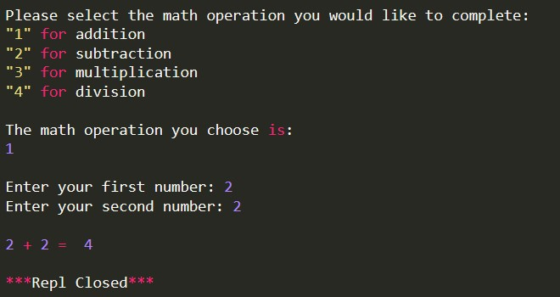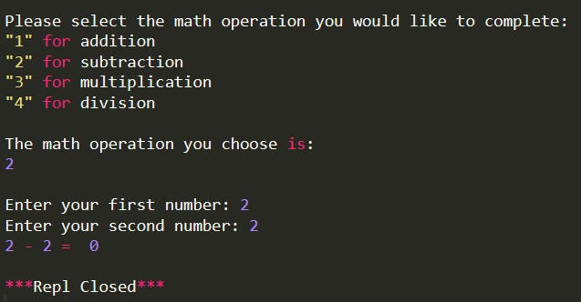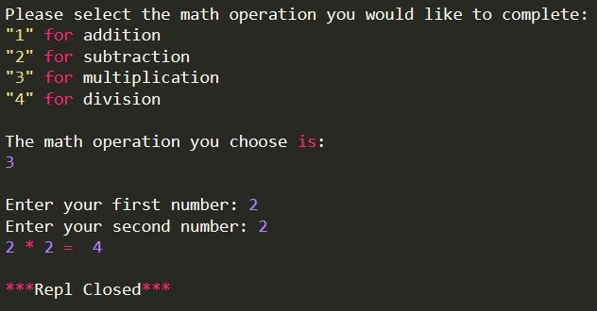

|  |
| --- |
| Example Output 4 (Division):    **(25 marks)** |
| **SOURCE CODE & OUTPUT:**      **Addition**    **Substraction**    **Multiplication**    **Division** |

|  |
| --- |
| **Question 2**  Construct a Python program to create the multiplication table pattern by using **looping statement**. You need to get an input from the user. (Choose other number from sample output given).      Example Output:      **(25 marks)** |
| **SOURCE CODE & OUTPUT:**    **Output** |

|  |
| --- |
| **Question 3**    **Figure 1**  Given car and brand in Figure 1. Using a suitable python list method, write a coding to:   1. Add a new element “Pesona” after “Jazz” in car. 2. Change “Hyundai” to “Proton” in brand. 3. Remove “Honda” in brand. 4. Sort brand in descending order. 5. Combine car and brand.   **(25 marks)** |

|  |
| --- |
| **SOURCE CODE & OUTPUT:**  **Question a.**    **Question b.**    **Question c.**    **Question d.**    **Question e.**    **Output Question a**    **Output Question b**    **Output Question c**    **Output Question d**    **Output Question e** |
| **CONCLUSION:**  **So, from this exercise we learn on how to use if else if statement to make multiple selection for calculator app, we also learn on using nested loop to make a pyramid of number, Lastly, we also learn on using multiple list method to organize our list better** |